

(A Constituent College of Somaiya VidyaviharUniversity)

# Batch: *A-4* Roll No.: *16010422211* Experiment No.: *02*

**Aim:** To Map EER diagram drawn in experiment no.1 to relational model.



**Resources needed:** MS-office



called E with n distinct attributes i.e. a separate relation with name E and n distinct columns.

1. Any weak entity set A having attributes a1, a2,..n and a strong entity set B on which A depends, having primary key attributes as b1, b2, …, bn is reduced into a relation schema called A with one attribute for each member of set

{ a1, a2,…, an} U {b1, b2, ……. , bn}

1. Any relationship set R having a1,a2,…,an as a set of attributes formed by union of the primary keys of each of the entity sets participating in R and b1, b2,….,bn as set of descriptive attributes is reduced into a relation schema called R with one attribute for each member of the set {a1, a2, …. ,an} U {b1, b2, …., bn}

# Primary key of relationship set is decided as follows

For **binary many to many relationships** the union of primary key attributes from the participating entity sets is primary key.

For **binary one to one relationship set** the primary key of either of the participating entity set can be chosen as the primary key.

For **binary many to one or one to many relationship set** the primary key of the entity set on the many side of the relationship set serves as the primary key.

For **n-ary relationship sets without any arrows on its edges**, union of the primary key attributes of participating entity sets is a primary key.

For **n-ary relationship sets with an arrows on one of its edges**, union of the primary key attributes of participating entity sets is a primary key.

To remove redundancy we generally make separate relation schema for many to many relationship set with primary key and other attributes as mentioned above.

For one to one we combine relation schema of relationship set with relation schema of either sides of entity sets relation schema.

For one to many and many to one we combine relation schema of relationship set with relation schema of entity set on many side entity set.

We don’t make separate relation schema for identifying relationship set.Every composite attribute A having subparts a1, a2,…,an is represented by separate column for each subpart in relation schema of the associated entity set.

For **multivalued attribute** separate schema is form having columns as attributes of primary key of associated entity set and a column for multivalued attribute

For **overlapping generalization/specialization** create separate relation schemas for higher level as well as lower level entity sets.

Also include the foreign key constraint in lower level entityset for the primary key attributes of higher level entity set.

For **disjoint generalization/specialization** create separate relation schemas only for every lower level entity set(higher level entity set’s attributes are inherited so add columns for same) and not for higher level entity set.

No separate relation is required to represent the **aggregation** the relation created from the defining relationship is used instead (design schema for relationship set treated as entity set carefully)



# Results: (Document printout/handwritten)

* 1. Relational model

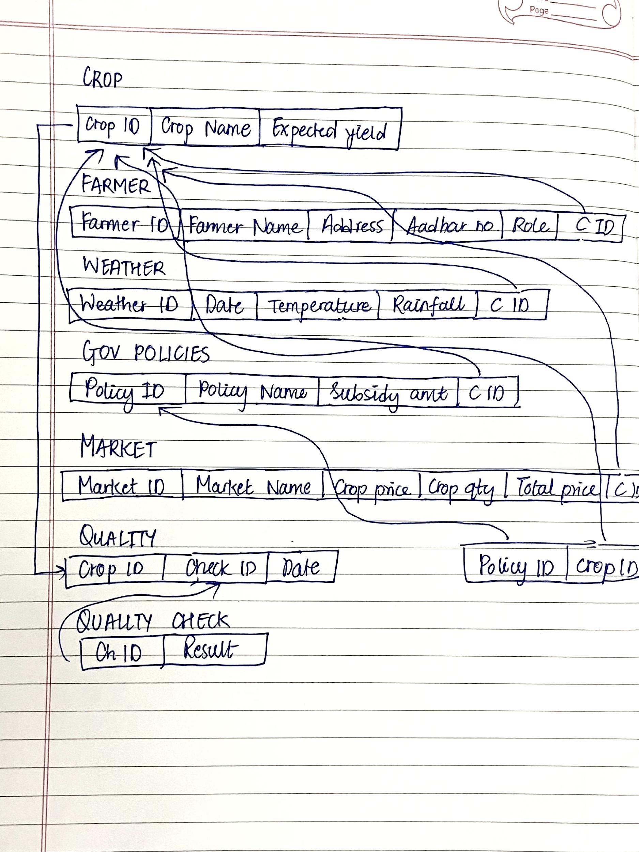

# Example:

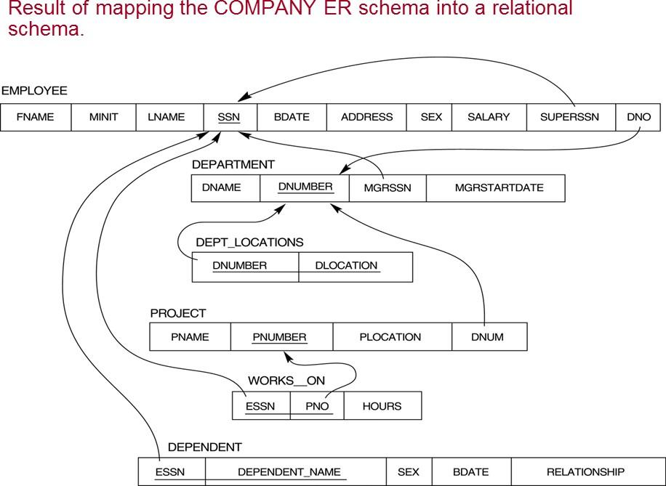



**Outcomes:**

CO: Realize the features of Relational Database Management System.



**Questions:**

**Q1 Explain generalization and specialization with example**

*Generalization and specialization are two fundamental concepts in DBMS, used in the process of designing a database schema.*

*GENERALIZATION: It is the process of abstracting common properties and multiple entities into more generalized or higher entity. In other words, we identify common attributes & relationships among different entities into a parent entity also known as a superclass. For eg; crop entity is the generalization of all crop types.*

*SPECIALIZATION: It is the reverse process of Generalization. It involves defining more specific entities based on a generalized entity. Weather, farmer etc are the example of specialized entities.*

**Q2 what is physical and logical data independence in DBMS.**

*PHYSICAL DATA INDEPENDENCE is defined as the ability to make changes in the structure of the lowest level of the Database Management System (DBMS) without affecting the higher-level schemas.*

*LOGICAL DATA INDEPENDENCE is defined as the ability to make changes in the structure of the middle level of the Database Management System (DBMS) without affecting the highest-level schema or application programs.*



**Conclusion:**

*Understood how to map eer diagram to relational model.*



**Reference books:**

1. Elmasri and Navathe, “Fundamentals of Database Systems”, 6th Edition, Pearson Education
2. Korth, Slberchatz,Sudarshan, :”Database System Concepts”, 6th Edition, McGraw – Hill